Stage 1 – Hey, you guys wanna see my video?
COURSE DESIGNER: TreVon Barber
SCORING: Comstock 28 rounds.
TARGETS: 14 cardboard targets
SCORED HITS: 2 Best hits per carboard will be scored.

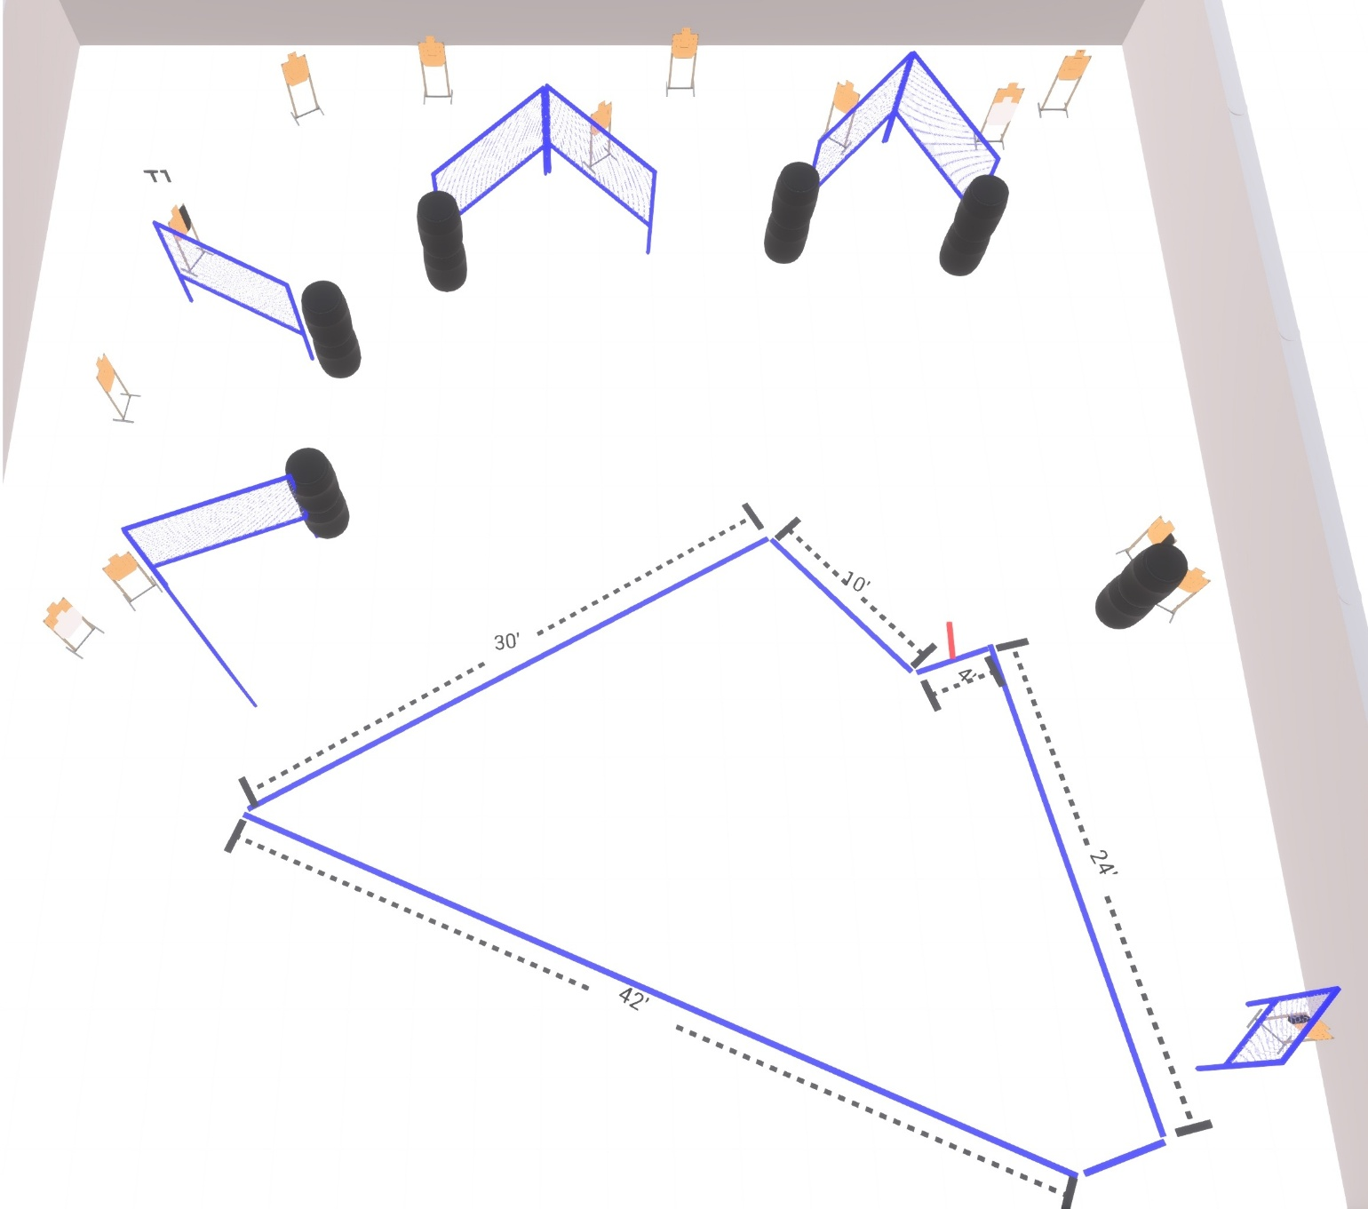

Written Stage Briefing:

Stage 1 – Hey, you guys wanna see my video? - is a 28 round, 140 point, Comstock Course. There are 14 cardboard targets.

Starting straddling the start stick.
Handgun is unloaded and holstered, wrists below belt.
PCC is unloaded held in both hands, stock on belt.

On the audible start signal, engage targets from within the shooting area.

USPSA / NROI Range Commands:
- Make Ready
- Are you ready?
- Standby
- If finished, unload and show clear
- If clear, hammer down and holster (Handgun)
If clear, hammer down and flag (PCC)
If clear, cylinder closed and holster (Revolver)
- Range is clear

Setup Notes:
10 Single Wall Stands
3 Double Wall Stands
7 Full Walls
1 Half Wall
14 Target stands / 28 target sticks
12+ Barrels

